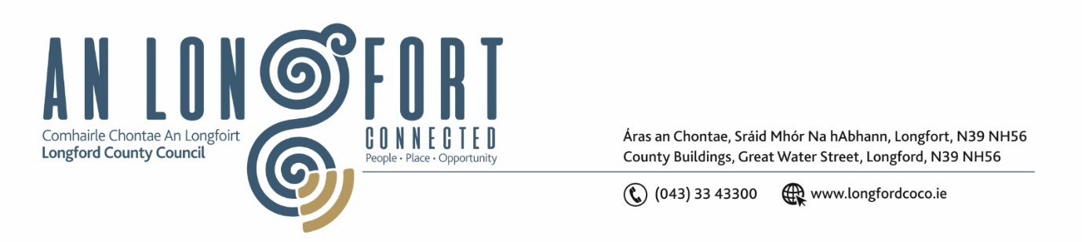

**LONGFORD MUNICIPAL DISTRICT**

***Please note meeting will be held in the Council Chamber, Aras an Chontae and via Microsoft Teams***

**19 September 2023**

**To: Each Member of Longford Municipal District.**

**Dear Member,**

You are requested to attend the Meeting of Longford Municipal District to be held in **the Council Chamber, Aras an Chontae** and **via Microsoft Teams** on **Wednesday 27 September 2023 at 4pm** to transact business, as set out on the agenda hereunder.

**Yours sincerely**,

_______________

**Claire McNabola**

**Meetings Administrator**

**AGENDA**

Prayer before meeting.

**1.** Confirmation of Minutes:

1. Longford Municipal District Meeting held on Wednesday 26 July 2023 – enclosed.

**2.** Matters arising from Minutes.

**3.** Declaration of Interest by Members.

**4.** Management Report

**5.** To approve a Statement of Consistency of the Draft Longford Local Economic and Community Plan 2023 - 2029 with the following:-

1. The core strategy and the objectives of the Longford County Development Plan 2021-2027;
2. The Eastern & Midland Regional Assembly Regional Spatial & Economic Strategy 2019 - 2031;
3. The economic and community elements of the Draft Local Economic and Community Plan are consistent with each other.

**6.** Consideration of Part VIII No. 109 – Proposed extension to St. John’s Graveyard, Battery Road, Abbeycartron, Longford Town. - Report in accordance with Section 179 of the Planning and Development Act 2000 (as amended) and Part 8 of the Planning & Development Regulations 2001 (as amended)

**7.** Consideration of Taking in Charge Longford Business and Technology Park – report enclosed

**8.** **Notices of Motions, submitted by Councillors, as listed hereunder –**

**Councillor Gerry Warnock**

1. I am calling on Longford Municipal District to vigorously engage with Uisce Eireann to immediately complete the taking in charge of sanitary infrastructure at Cartrun Breac Estate.
2. I'm calling on Longford Municipal District to organise a contractor to carry out maintenance works on the Longford Royal Canal Walkway. Provision was made in the LCC Budget 2023 to do these works, but this has not been advanced. The condition of this well utilised walkway is appalling and has nearly negated the significant capital investment that totally transformed the amenity back in 2019.
3. I am calling for a review of our public infrastructure within The Mall with a view to developing a master plan to include additional carparking, lighting, ramps and installation of public CCTV poles and cameras. Over the last number of years, The Mall has seen a significant increase in footfall in no small part due to the success of the Leisure Centre, the upgrading of the walking trail, Longford Park Run and other Running Groups, as well as the continued use of the Astro Turf Pitches. This is all hugely welcome, but we need to ensure that our infrastructure is in line with this increased usage as well as being mindful of public safety.

**Councillor Seamus Butler**

1. That the lower green area in the St Emer’s Estate requires a surface water drainage scheme to allow the cutting of grass throughout the growing season. I respectfully request that these works are carried out before next year’s grass cutting season.
2. Whereas the Local Government Act 2001 as amended in the 2014 Act, Schedule 14A, subject to Section 131A that it is a reserved function of a Municipal District to make a resolution to determine the manner in which fees for parking shall be disposed of, I hereby propose that the Executive furnish those fees to the October meeting of Longford Municipal District by way of an Agenda item to be voted on by the Members of Longford Municipal District.

**Councillor John Browne**

I call on Longford County Council to have bicycle stands installed outside the entrances at the Tesco Shopping Centre and at the Public Library.